|  |
| --- |
|  |
| CRYPTOGRAPHIC DATA TRANSMISSION THROUGH Li-Fi  OPTICAL COMMUNICATION SYSTEM PROJECT [EE-473] |
| |  |  |  | | --- | --- | --- | | ENGR. NOMAN AHMED SIDIQQUI & ENGR. MEHWISH | ELECTRONIC ENGINEERING DEPARTMENT | SIR SYED UNIVERSITY OF ENGINEERING & TECHNOLOGY | |

**CRYPTOGRAPHIC**

**DATA TRANSMISSION THROUGH Li-Fi**

**OPTICAL COMMUNICATION SYSTEM (EE_473)**

**Submitted by**

**MUHAMMAD HASSAN 2017-EE-069**

**AAZIB AHMED ANSARI 2017-EE-078**

**MIRZA HAMZA UMER 2017-EE-079**

**MUAMMAD USMAN 2017-EE-107**



**8th Semester Project Report**

Department of Electronic Engineering

Sir Syed University Of Engineering and Technology, Karachi

**ACKNOWLEDGEMENT**

We would like to express our deepest appreciation to all those who provided us the possibility to complete this project and report.  A special gratitude we give to our project teacher, **ENGR. NOMAN AHMED SIDDIQUI,** whose contribution in stimulating suggestions and encouragement, helped me to coordinate our project especially in writing this report.

Furthermore, we would also like to acknowledge with much appreciation the crucial role of **ENGR.MEHWISH** who gave the guidance to in our project and the necessary materials to complete the project. A special thanks goes to my Group Members who help me to assemble the parts and gave suggestion about the task. Last but not least, many thanks go to the head of the project, whose have invested his full effort in guiding the team in achieving the goal. I have to appreciate the guidance given by other supervisor as well as the panels especially in our project presentation that has improved our presentation skills thanks to their comment and advices.

**TABLE OF CONTENTS**

**Page**

**Acknowledgment** 02

**Table of Contents** 03

**List of Figures**  04

**Abstract** 05

1. **INTRODUCTION**
   1. Introduction 06

1.2 Literature Review 07

* 1. Theoretical background 07

1. **PROJECT BLOCK DIAGRAM**

2.1 Block Diagram 09

2.2 Description of Blocks 09

1. **METHODOLOGY**
   1. Working of the Circuit 10
2. **OBSERVATIONS & RESULTS** 
   1. Observation 11
   2. Results 12
   3. Applications of Li-Fi 13
3. **CONCLUSION & FUTURE RECOMMENDATION** 
   1. Conclusion & Future Recommendation 15

**REFRENCES** 16

**APPENDIX A: Coding**

**APPENDIX B: Data Sheet**

**APPENDIX C: Cost Analysis**

**LIST OF FIGURES**

**Page**

Figure 1.1 Project Block Diagram 06

Figure 1.2 Li-Fi VS Wi-Fi 08

Figure 2.1 Project Block Diagram 09

Figure 3.1 Li-Fi using Arduino 10

Figure 4.1 Figure describing Li-Fi 11

Figure 4.2 Results 12

Figure 4.3 Li-Fi Process 13

**ABSTRACT**

In our project, the Wireless Fidelity (Wi-Fi) hotspot is rapidly increasing signal is sure to suffer. They are vulnerable to hackers as it penetrates through walls easily. The major concerns are security and speed. Li-Fi technology is said to overcome this. In our project, there is a new technology that using the Flash Light of a mobile phone sends the data through the “Li-Fi Android Application” that the intensity faster than the human eyes can see. In this Project Data Encryption depends on Flash Light ON state Duration. In the future of this project, we will see the data for smartphones, tablets, and laptops transfer using the sunshine during a room. Maybe a Li-Fi is a fast optical version of Wi-Fi, this technology on light communication.

**INTRODUCTION**

* 1. **Introduction:**

****With the drastic increase in the use of digital gadgets such as personal computers, smartphones, and tablets, a most daily job now performed digitally. This makes everything easier, faster, and more efficient. Given the option, most people today would prefer doing things electronically rather than sitting down with a pen and paper. In fact, given a choice, people would like to click an image rather than typing things out manually. In these documents, it is easy to increase the document to be scanned and shared via an electronic. However, a scan is merely an image capture of the original document, so it cannot be searched through in any way. In current times the innovation is growing so quickly that every nation is understood with the event of technology. Technology is changing the way of imagination. In upcoming years individuals can transmit the data through light. In which Harald Hass successfully demonstrated that the information can transmit through the light, which is known as Li-Fi. Li-Fi gives more speed than Wi-Fi. WiFi is that the present technology; however, in the future, there will Li-Fi, which can utilize for transmission of the knowledge. The innovation is changing in different fields. So, for the sake of securing data we set few words in our coding which depend on Flash light “ON” State Duration and cryptographic methods for the authentication of a user to stop any third party personal from retrieving.

**Figure 1.1 Li-Fi**

For example transportation, smartphones, banks, and so on. ATM cards are presently used, butafter demonetization, people started using ATM card more those who do not know how to use. ATM card they also learn and started using ATM cards, As users are increasing, so frauds are also increasing and to give security to the cards technology is using different ways of techniques like cards are becoming replaced via cardless. For example, Samsung pay, Google wallet in which we can pay from smartphones.

* 1. **Literature Review:**

The proposed system is being developed for the transaction System, security purpose. Security is necessary to hide the details of user credentials so that no one can hack it. For security, the existing card is replaced by a cardless system. The method proposed is to aim for encryption of user credentials through the Advanced Encryption Standard Algorithm (AESA). The encrypted credential will be sent through flashlight (Li-Fi technology), and at the receiver side, it will detect through LDR sensors, send the signal to the Arduino board. In Arduino, user credentials will get decrypt through AESA, and then Arduino send user credentials to the computer, and we get original data.

* 1. **Theoretical Background:**

Li-Fi (also written as Li-Fi) is a [wireless communication](https://en.wikipedia.org/wiki/Wireless) technology which utilizes light to transmit data and position between devices. The term was first introduced by [Harald Haas](https://en.wikipedia.org/wiki/Harald_Haas_(engineer)) during a 2011 [TED Global](https://en.wikipedia.org/wiki/TED_(conference)) talk in [Edinburgh](https://en.wikipedia.org/wiki/Edinburgh).

In technical terms, Li-Fi is a light communication system that is capable of transmitting [data](https://en.wikipedia.org/wiki/Data) at high speeds over the [visible light](https://en.wikipedia.org/wiki/Visible_spectrum), [ultraviolet](https://en.wikipedia.org/wiki/Ultraviolet), and [infrared](https://en.wikipedia.org/wiki/Infrared) spectrums. In its present state, only [LED lamps](https://en.wikipedia.org/wiki/LED_lamp) can be used for the transmission of visible light.

In terms of its [end use](https://en.wikipedia.org/wiki/End_user), the technology is similar to [Wi-Fi](https://en.wikipedia.org/wiki/Wi-Fi) — the key technical difference being that Wi-Fi uses [radio frequency](https://en.wikipedia.org/wiki/Radio_frequency) to induce a voltage in an antenna to transmit data, whereas Li-Fi uses the modulation of light intensity to transmit data. Li-Fi can theoretically transmit at speeds of up to 100 Gbit/s. Li-Fi's ability to safely function in areas otherwise susceptible to electromagnetic interference (e.g. [aircraft cabins](https://en.wikipedia.org/wiki/Aircraft_cabin), hospitals, military) is an advantage. The technology is being developed by several organizations across the globe. Li-Fi is a derivative of [optical wireless communications](https://en.wikipedia.org/wiki/Optical_wireless_communications) (OWC) technology, which uses light from [light-emitting diodes](https://en.wikipedia.org/wiki/Light-emitting_diode) (LEDs) as a medium to deliver network, mobile, high-speed communication in a similar manner to [Wi-Fi](https://en.wikipedia.org/wiki/Wi-Fi). [Visible light communications](https://en.wikipedia.org/wiki/Visible_light_communication) (VLC) works by switching the current to the LEDs off and on at a very high speed, too quick to be noticed by the human eye, thus, it does not present any flickering. Although Li-Fi LEDs would have to be kept on to transmit data, they could be dimmed to below human visibility while still emitting enough light to carry data.[[7]](https://en.wikipedia.org/wiki/Li-Fi#cite_note-Condliffe-7) This is also a major bottleneck of the technology when based on the visible spectrum, as it is restricted to the illumination purpose and not ideally adjusted to a mobile communication purpose. Technologies that allows as roaming between various Li-Fi cells, also known as handover, may allow to seamless transition between Li-Fi. The light waves cannot penetrate walls which translates to a much shorter range, and a lower [hacking](https://en.wikipedia.org/wiki/Hacker) potential, relative to Wi-Fi. Direct line of sight is not necessary for Li-Fi to transmit a signal; light 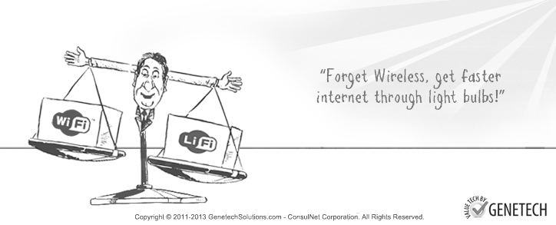reflected off walls can achieve 70 [Mbit/s](https://en.wikipedia.org/wiki/Mbit/s).

**Figure 1.2 Li-Fi VS Wi-Fi**

Li-Fi has the advantage of being useful in electromagnetic sensitive areas such as in aircraft cabins, hospitals and nuclear power plants without causing [electromagnetic interference](https://en.wikipedia.org/wiki/Electromagnetic_interference). Both Wi-Fi and Li-Fi transmit data over the [electromagnetic spectrum](https://en.wikipedia.org/wiki/Electromagnetic_spectrum), but whereas Wi-Fi utilizes radio waves, Li-Fi uses visible, ultraviolet, and infrared light. While the US Federal Communications Commission has warned of a potential spectrum crisis because Wi-Fi is close to full capacity, Li-Fi has almost no limitations on capacity. The visible light spectrum is 10,000 times larger than the entire [radio frequency](https://en.wikipedia.org/wiki/Radio_frequency) spectrum. Researchers have reached data rates of over 224 Gbit/s, which was much faster than typical fast [broadband](https://en.wikipedia.org/wiki/Broadband) in 2013. Li-Fi is expected to be ten times cheaper than Wi-Fi. Short range, low reliability and high installation costs are the potential downsides.

Bg-Fi is a Li-Fi system consisting of an application for a mobile device, and a simple consumer product, like an IoT ([Internet of Things](https://en.wikipedia.org/wiki/Internet_of_Things)) device, with color sensor, microcontroller, and embedded software. Light from the mobile device display communicates to the color sensor on the consumer product, which converts the light into digital information. Light emitting diodes enable the consumer product to communicate synchronously with the mobile device.

**PROJECT BLOCK DIAGRAM**

* 1. **Block Diagram:**

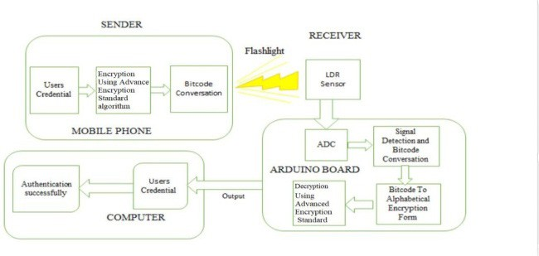

**Figure 2.1 Project Block Diagram**

* 1. **Description of blocks:**

**SENDER:** At sender side the smart phone is connected to an app Li-Fi projects, from where the data is type to display it con the LCD. The only work from the sender side is to flash the message at the LDR to transmit the message.

**RECIEVER:** The receiver side work starts from the LDR module at the time when it receives message in the form of light then this signal goes through the Arduino where it processes and the final result is displayed to the LCD screen.

**METHODOLOGY**

* 1. **Working of the circuit:**

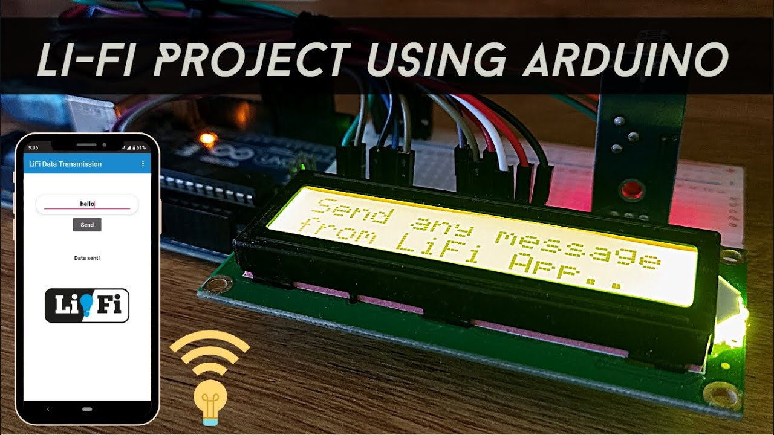The system flow diagram for the proposed system. The system architecture shows the smartphone, which will play an important role, having user’s credentials. First, the user’s credentials will encrypt using the public key of the AESA. The encrypted form will be converted into bit code, and then the bit code will be transmitted through the flashlight of a smartphone to the receiver’s end and transmitted successfully. At the receiver side, the LDR sensor is integrated into Arduino. In Arduino, ADC signal detection and the bit code conversion is performed, bit using AESA. LDR sensor will detect the flashlight of the smartphone. The LDR sensor will send the signal to the ADC. Signal first convert into analog and then digital form. Then the digital signal will convert into bit code and bit code to the alphabetical encrypted form. Finally, the encrypted form is decrypted by using the private key of the AESA. The output will be shown on the computer as the original user’s credentials. Ultrasonic sensors are used to sense the traffic and are placed around the entrances of intersections. The ultrasonic sensors judge the traffic itself and then send it to the microcontroller after every 5 seconds. When the traffic is detected on the straight lane in the north-south direction, it then checks the east and west directs signal, whether it is green or not.

**Figure 3.1 Li-Fi using Arduino**

**OBSERVATIONS & RESULTS:**

* 1. **Observation:**

This is an experimental procedure which tells that it is possible to transfer data from one point to another point with the help of the Light.

The outcome of the detailed research is positive. And following are the points which will tell us about the advantages of Laser communication systems.

## **Enormous Bandwidths**

The data holding capability of the system is increased at a great rate. As this data holding capacity is directly proportional to the frequency of signal.

## **Low transmission loss**

As the signal is directly transmitted to the other end, and if no obstruction is in between the light, then the transmission loss is very low.

## **Invulnerable to noise**

The Li-Fi communication system are immune to noise and cross talks. And the systems which does not use the optical fibers are also immune to noise up to a limit, as there is very less transmission

## **High Data Rate**

The data rate in the Li-Fi communication system is very high.

## **Electrical Isolation**

Light is not affected by the electrical shocks. So both of them can operate near high voltage devices.

## **Small size and weight**

The size and weight is very small. So they are easy to handle. They occupy very less space as compared to the electrical equipment. Due to these rewards it makes it possible to use in aircrafts and satellites more successfully.

## **Signal security**

The signal is fully secured.

## **Cheap and good availability**

Since Li-Fi technology is simply based on light which is available easily. And they are cheap also, which makes an efficient and cheap communication system.

## **Reliability**

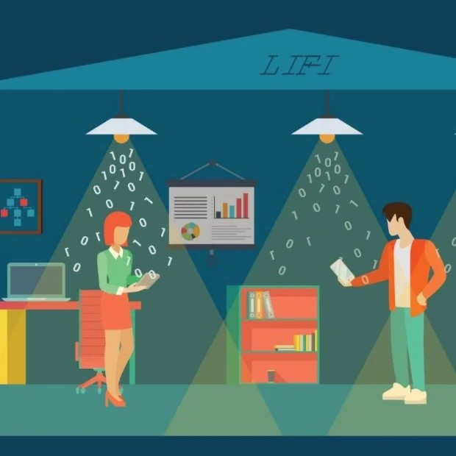There is less attenuation of the signal, so the integrity of the signal is saved. Therefore it makes the system more reliable.

**Figure 4.1 Figure Describing Li-Fi**

**4.2 Results:**

Now that we have measured the performance of the system, a real test of the Li-Fi quality was in order. I connected my smartphone to the input, and the output to a set of LCD connected through an Arduino.

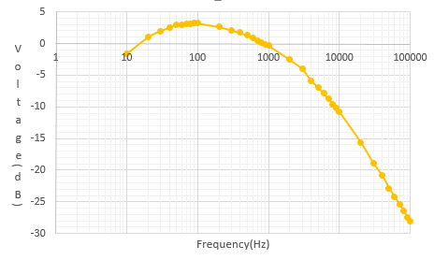When message is send through the flash of the smartphone which is conveyed to the LCD using the LDR it shows that it is working. So that's how you can build a very basic Li-Fi-based communication system for under 1000 rupees. If you want 2-way communication, build a second copy of the system so that each side has both a receiver and transmitter. If you build a system with multiple channels going in each direction, you may want to use linear polarizers to prevent "cross talk" and allow you to pack more receivers in a small space.

**FIGURE 4.2 RESULTS**

**4.3 Application of Li-Fi:**

With the short wave radiation as used by Li-Fi, the communications cannot penetrate through walls and doors. This makes it more secure and makes it easier to control access to a network. As long as [transparent materials](https://en.wikipedia.org/wiki/Transparent_materials) like windows are covered, access to a Li-Fi channel is limited to devices inside the room.

### **Home and building automation**

It is predicted that future home and building automation will be highly dependent on the Li-Fi technology for being secure and fast. As the light cannot penetrate through walls, the signal cannot be hacked from a place that is not visible through the window.

### **Underwater application**

Most [remotely operated underwater vehicles](https://en.wikipedia.org/wiki/Remotely_operated_underwater_vehicle) (ROVs) are controlled by wired connections. The length of their cabling places a hard limit on their operational range, and other potential factors such as the cable's weight and fragility may be restrictive. Since light can travel through water, Li-Fi based communications could offer much greater mobility. Li-Fi's utility is limited by the distance light can penetrate water. Significant amounts of light do not penetrate further than 200 meters. Past 1000 meters, no light penetrates.

### **Aviation**

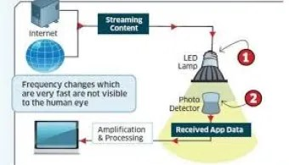Efficient communication of data is possible in airborne environments such as a commercial [passenger aircraft](https://en.wikipedia.org/wiki/Airliner) utilizing Li-Fi. Using this light-based data transmission will not interfere with equipment on the aircraft that relies on [radio waves](https://en.wikipedia.org/wiki/Radio_wave) such as its [radar](https://en.wikipedia.org/wiki/Radar).

**Figure 4.3 Li-Fi Process**

### **Hospital**

Many treatments now involve multiple individuals, Li-Fi systems could be a better system to transmit communication about the information of patients. Besides providing a higher speed, light waves also have little effect on [medical instruments](https://en.wikipedia.org/wiki/Medical_equipment). Wireless communication can be done during the use of such medical instruments without having to worry about radio interferences hindering the efficiency of the task.

### **Vehicles**

[Vehicles](https://en.wikipedia.org/wiki/Vehicle) could communicate with one another via front and back lights to increase road safety. Street lights and traffic signals could also provide information about current road situations.

### **Industrial automation**

Anywhere in industrial areas data has to be transmitted, Li-Fi is capable of replacing [slip rings](https://en.wikipedia.org/wiki/Slip_rings), sliding contacts and short cables, such as [Industrial Ethernet](https://en.wikipedia.org/wiki/Industrial_Ethernet). Due to the real time of Li-Fi (which is often required for automation processes) it is also an alternative to common industrial Wireless LAN standards. Fraunhofer IPMS, a research organisation in Germany states that they have developed a component which is very appropriate for industrial applications with time sensitive data transmission.

### **Advertising**

[Street lamps](https://en.wikipedia.org/wiki/Street_light) can be used to display advertisements for nearby businesses or attractions on [cellular devices](https://en.wikipedia.org/wiki/Mobile_phone) as an individual passes through. A customer walking into a store and passing through the store's front lights can show current sales and promotions on the customer's cellular device.

### **Education**

Students and teachers can be part of a more active educational community in a classroom that is Li-Fi enabled. Students with devices such as [smartphones](https://en.wikipedia.org/wiki/Smartphone) or [laptops](https://en.wikipedia.org/wiki/Laptop) can communicate with the teacher, or with each other, to create a more efficient learning environment. Teachers can be able to collaborate with students to help better understand class material.

**CONCLUSION & FUTURE RECOMMENDATION:**

**5.1 Conclusion & Future Recommendations:**

Thus, the WIFI and Hot spots used to every bulb, if Li-Fi technology can be put into the practical. It conducted faster, simple, and efficient wireless digital communication. This technology makes us proceed with the safer, cleaner, and brighter future. We find the new in the future, data for smartphones, tablets, and laptops can be transmitted through light in a room by using Li-Fi. The researcher is developing a micron-sized LEDs that can flicker on and off around 1,000 times quicker than larger than LEDs. The data is transmitted faster and takes up less space, so the further boosts the channel of communication, we could add more LEDs. This technology many problem solve, like shortage of frequency bandwidth and also allow the web where the normal radio-based wireless isn’t allowed such aircraft and hospitals.

**REFRENCES**

[1] “The Way Back Machine Visiblelightcomm.com” for Visible Light Communications Archived 29 August 2013.

[2] “Way Back Machine, Motherbpard Beta, Brian Merchant: An Internet of Light: Going Online with LEDs and the First Li-Fi Smartphone” Archived 11 January 2014.

[3] "The Future's Bright"-. The Caledonian Mercury. 29 November 2013. Archived from the original on 4 November 2015. Retrieved 29 November 2015.

[4] "Applications of Li-Fi – pure LiFi™". Pure LiFi™. Archived from the original on 20 November 2016. Retrieved 15 November 2016.

[5] "Li – Fi Technology, Implementations and Applications". International Research Journal of Engineering and Technology. Archived from the original on 17 November 2016.

[6] "Harald Haas: Wireless data from every lightbulb" .ted.com. Archived from the original on 8 June 2017.

[7]. Engineering, N.Z.C.f.A., Regional Energy Survey 2006. 2008: Christchurch.

[8]. Kittle, P.A., Alternate Daily Cover Materials And Subtitled - The Selection

Technique. 1993, Rusmar Incorporated West Chester, PA.

For more material type visit: <https://libguides.murdoch.edu.au/IEEE/all>

**APPENDIX-A**

**CODING**

#include <Wire.h>

#include <LiquidCrystal_I2C.h>

LiquidCrystal_I2C lcd(0x27, 16, 2);

#define ldr 8

int val;

int val2;

String duration;

void setup() {

// put your setup code here, to run once:

Serial.begin(9600);

pinMode(ldr, INPUT_PULLUP);

lcd.init();

lcd.backlight();

lcd.clear();

lcd.print("OPTICAL COMMUNICATION");

delay(3000);

lcd.clear();

lcd.print("Send any message");

lcd.setCursor(0,1);

lcd.print("from LiFi App..");

delay(3000);

}

void loop() {

// put your main code here, to run repeatedly:

int val = digitalRead(ldr);

while(val == 0)

{

int val2 = digitalRead(ldr);

duration += val2;

if(duration == "001")

{

Serial.println("Received message: hi");

lcd.clear();

lcd.print("hi");

}

if(duration == "0001")

{

Serial.println("Received message: hello");

lcd.clear();

lcd.print("hello");

}

if(duration == "00001")

{

Serial.println("Received message: how are you?");

lcd.clear();

lcd.print("how are you?");

}

if(duration == "000001")

{

Serial.println("Received message: I am fine");

lcd.clear();

lcd.print("I am fine");

}

if(duration == "0000001")

{

Serial.println("Received message: ok");

lcd.clear();

lcd.print("ok");

}

if(duration == "00000001")

{

Serial.println("Received message: good morning");

lcd.clear();

lcd.print("good morning");

}

if(duration == "000000001")

{

Serial.println("Received message: good afternoon");

lcd.clear();

lcd.print("good afternoon");

}

if(duration == "0000000001")

{

Serial.println("Received message: good evening");

lcd.clear();

lcd.print("good evening");

}

if(duration == "00000000001")

{

Serial.println("Received message: thank you");

lcd.clear();

lcd.print("thank you");

}

if(duration == "000000000001")

{

Serial.println("Received message: sorry");

lcd.clear();

lcd.print("sorry");

}

if(val2 == 1)

{

duration = "";

break;

}

delay(200);

}

}

**APPENDIX-B**

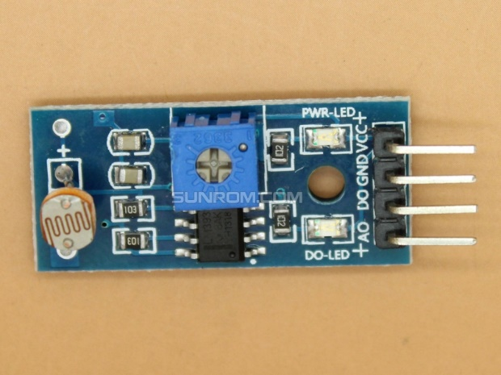**DATA SHEET**

**Light Sensing Module - LDR 4589**

**Specifications**

* Operating Voltage: 3.3V to 5V DC
* Operating Current: 15ma
* Output Digital - 0V to 5V, Adjustable trigger level from preset
* Output Analog - 0V to 5V based on light falling on the LDR
* LEDs indicating output and power
* PCB Size: 3.2cm x 1.4cm
* LM393 based design

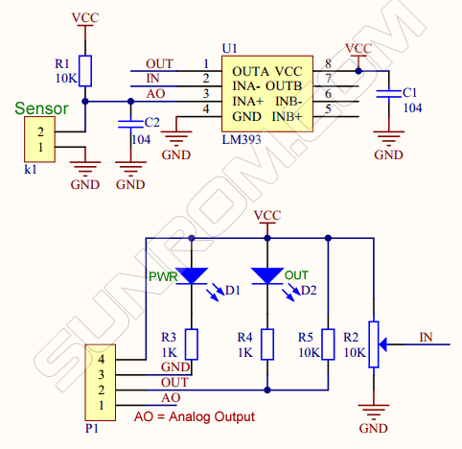**Board Schematic**

​

**Pin details**

* VCC = 3.3V to 5V DC
* GND = Ground
* DO = Digital Output
* AO = Analog Output

### **How to use**

* Photosensitive resistor module most sensitive to environmental light intensity is generally used to detect the ambient brightness and light intensity.
* Module light conditions or light intensity reach the set threshold, DO port output high, when the external ambient light intensity exceeds a set threshold, the module D0 output low;
* Digital output D0 directly connected to the MCU, and detect high or low TTL, thereby detecting ambient light intensity changes;
* Digital output module DO  can directly drive the relay module, which can be composed of a photoelectric switch;
* Analog output module AO and AD modules can be connected through the AD converter, you can get a more accurate light intensity value

**APPENDIX-C**

**COST ANALYSIS OF THE PROJECT**

|  |  |  |  |  |
| --- | --- | --- | --- | --- |
| **MAJOR EQUIPMENT SPECIFICATION & COST** | | | | |
| **S.No** | **Component Name** | **Description** | **QTY** | **Cost** |
| **1** | **Arduino UNO** | **Controller** | **01** | **500** |
| **2** | **LDR Module** | **Input** | **01** | **120** |
| **3** | **LCD Display** | **Output Display** | **01** | **340** |
| **4** | **i2c Module** | **LCD connector** | **01** | **100** |
| **Total Cost of the Project** | | | | **1060/=** |